**Ben-Gurion University of the Negev**

**Faculty of Engineering Sciences**

**Department of Software and Information systems Engineering**

**Deep Learning**

**Assignment 3**

**The purpose of the assignment**

Enabling students to experiment with building a recurrent neural net and using it on a real-world dataset. In addition to practical knowledge in the “how to” of building the network, an additional goal is introducing the students to the challenge of integrating different sources of information into a single framework.

**Submission instructions:**

1. The assignment due date: 11.7.24
2. The assignment is to be carried out using PyTorch.
3. Submission in **pairs** only. Only **one copy** of the assignment needs to be uploaded to Moodle.
4. Plagiarism of any kind (e.g., GitHub) is forbidden.
5. Submit your work using a notebook.
6. The entire project will be submitted as a single zip file, containing both the report (in PDF form only) and the code. It is the students’ responsibility to make sure that the file is valid (i.e. can be opened correctly).

**Introduction**

In class we covered the topic of automatic sentence completion/generation. In addition to the completion of “regular” sentences, this technique can also be applied to other domains such as lyrics and melodies generation (a nice example is [BachBot](https://soundcloud.com/bachbot)). In this task you will train a neural net to generate lyrics based on the provided melody.

During the training of the model you will have access both to the lyrics of a song and its melody. The melodies are stored in .mid (MIDI files) and contain various types of information – notes, the instruments used etc. You are encouraged to experiment with various methods to incorporate this information with the lyrics. During the test phase, you are required to automatically generate lyrics for a provided melody.

Please note that this assignment cannot be measured using objective (i.e., absolute) performance measures. Instead, we will be evaluating your approach to the solution, the implementation, and your analysis of your model’s performance.

**Instructions**

1. Please download the following:
   1. A .zip file containing all the MIDI files of the participating songs
   2. the .csv file with all the lyrics of the participating songs (600 train and 5 test)
   3. [Pretty_Midi](https://nbviewer.jupyter.org/github/craffel/pretty-midi/blob/master/Tutorial.ipynb), a python library for the analysis of MIDI files
2. Implement a recurrent neural net (LSTM or GRU) to carry out the task described in the introduction.
   1. During each step of the training phase, your architecture will receive as input one word of the lyrics. Words are to be represented using the Word2Vec representation that can be found online (300 entries per term, as learned in class).
   2. The task of the network is to predict the next word of the song’s lyrics. Please see Figure 1 for an illustration. You may use any loss function
   3. In addition to this textual information, you need to include information extracted from the MIDI file. The method for implementing this requirement is entirely up to your consideration. Figure 1 shows one of the more simplistic options – inserting the entire melody representation at each step.
   4. Note that your mechanism for selecting the next word should not be deterministic (i.e., always select the word with the highest probability) but rather be sampling-based. The likelihood of a term to be selected by the sampling should be proportional to its probability.
   5. You may add whatever additions you want to the architecture (e.g., regularization, attention, teacher forcing)
   6. You may create a validation set. The manner of splitting (and all related decisions) are up to you.
   7. You need to set “guidelines” (either fixed rules, preferably through the loss function) regarding the length of the generated text, the maximal number of words per line, etc. The goal is to make your lyrics look like those of an actual song.
3. The Pretty_Midi package offers multiple options for analyzing .mid files. Figures 2-4 demonstrate the types of information that can be gathered.
4. You can add whatever other information you consider relevant to further improve the performance of your model.

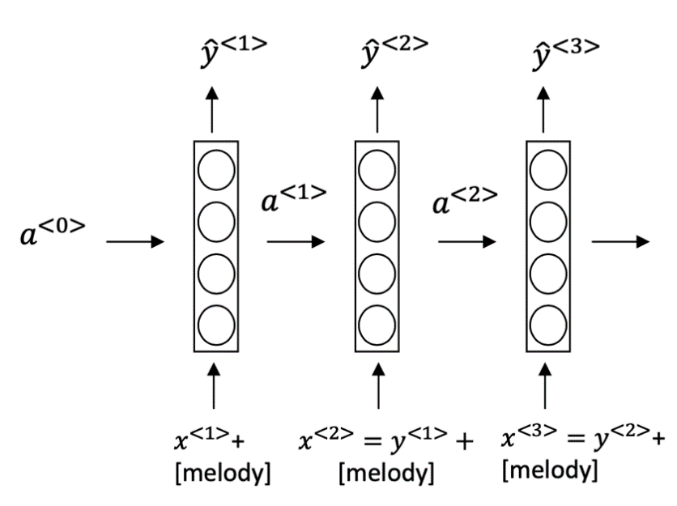

**Figure** **1:** an example of a simplistic way of combining the melody and lyrics

1. You are to evaluate two approaches for integrating the melody information into your model. The two approaches don’t have to be completely different (one can build upon the other, for example), but please refrain from making only miniature changes.

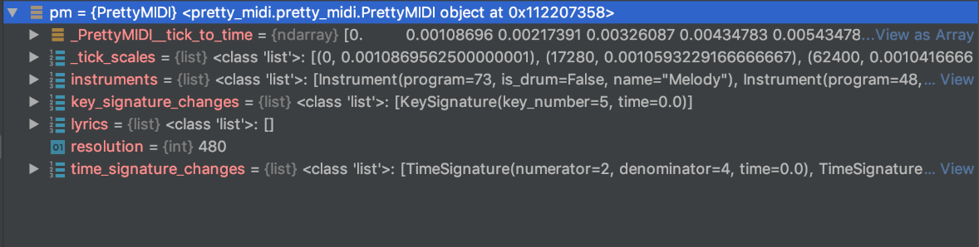

**Figure 2**: general .mid file information

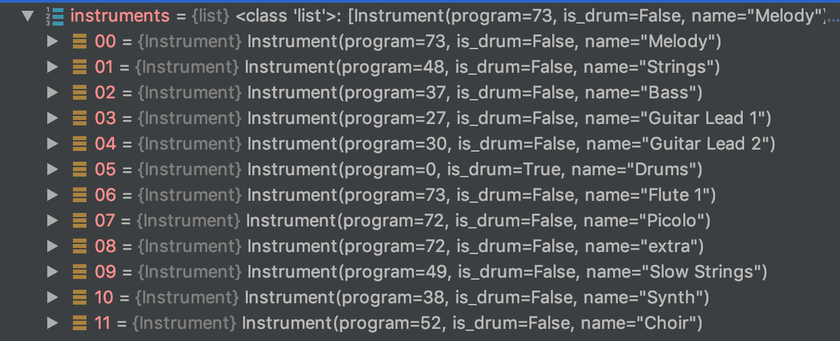

**Figure 3**: Instrument information of the analyzed file

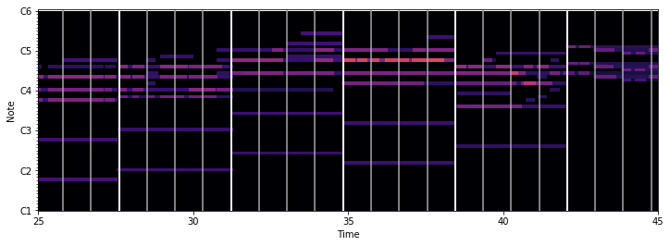

**Figure 4**: timing information of the analyzed file

1. Please include the following information in your report regarding the training phase:
   1. The chosen architecture of your model
   2. A clear description of your approach(s) for integrating the melody information together with the lyrics
   3. TensorBoard graphs showing the training and validation loss of your model.
2. Please include the following information in your report regarding the test phase:
   1. For each of the melodies in the test set, produce the outputs (lyrics) for each of the two architectural variants you developed. The input should be the melody and the initial word of the output lyrics. Include all generated lyrics in your submission.
   2. For each melody, repeat the process described above three times, with different words (the same words should be used for all melodies).
   3. Attempt to analyze the effect of the selection of the first word and/or melody on the generated lyrics.

Good Luck!

# Assignment 3 - lyrics generation using RNNs

## .Intorduction

* + - 1. Dataset analysis

Sinai Tbd add analysis of the dataset + lyrics

* + - 1. Melody analysis

Sinai Tbd add analysis of the melody (size,len etc)

## Methodology

### 2.1 Lyrics preprocessing

The preprocessing includes: 1) lowercase , 2) remove punctuation ,3) add end of sentence sign (‘eos’) 4) we keep ‘&’, it line break, so one of the prediction is line break.

### 2.2 text embedding

We used word2vec moudle to embeds the word to numeric vector, we used (As required) embedding entries per term. We train the moudle on the train dataset and get the contextual numeric representation.

### 2.3 input structure process

We preocess the lyrics in the next way: we use lstm mode, so the input should be a vector of size n, which in position is a differnet “time-line”, in the context of llm, the vector is a sentence in size n, and each position is diffrenent word. The output (target) is vector with the same size, while each position is the next word of the same position input vector.

The number of train vectour vary depends the sequnece len.

the code can be found in generate_sequence function in tools.py

### 2.4 Melody procesing ( MIDI files)

We use 2 approches to handle the midi files;

#### 2.4.1 graph embedding

We used a graph embedding method, ealborating describe in Lisena paper [1] MIDI2vec uses graph embedding techniques to represent MIDI files, capturing tempo, time signature, programs, and notes. It optimizes node2vec for generating embeddings that predict musical genre and metadata. This method achieves high accuracy with Feed-Forward Neural Networks, enabling scalable and automated metadata tagging in symbolic music collections. We use the implemented github repositoy [2], with the next parameters:

For the computing edgelist:

1) -n =100 (Number of groups of simultaneous notes to be taken in account for each MIDI)

For the converting to vectors:

1. walk_length = 5 (Length of walk per source)
2. –dimensions=50 (number of dimension)

The rest parameters are the deafult parameter ( added in the reference)

Finaly we got vector of 50 dimensions for each melody

#### 2.4.1 Sinai embedding

tbd

## 3. Model architecture

3.1 train vlaidation split:

We use 0.95 train and 0.05 validation. We expacting that the loss will decrease mainly in the train , and in the validation, It hards to beclieve that th loss reduces, becouase the complex task of predicting and generating lyrics. So in this case we think 5 percents will be more than enough.

3.2 model architecture

3.2.1 naïve cocncatenate word and midi vectors (Naïve)

We used lstm model with the next structure:

* + - 1. Concatenate word vector + midi vector
      2. Use LSTM configuration
      3. Fully connected layer, with vocabulary size output

3.2.2 merge parralel layers of midid and word vector (Merge)

1. single Dense layer with Relu for midi vector

2. concatenate the embededd densed midi layer and the word vector

3. Use LSTM configuration

4. Fully connected layer, with vocabulary size output

We use hyper-parameter optimization to fine-tune the model, the final parameters will be secribed. For each epoch we get output of the train and validation loss, and perplexity of the train and test moreover we generate and print lyrics (for make sense tracking)

### 3.3 generated lyrics rules

For the generated text we use the next pipeline ( combine deterministic and stochastic attributes):

Define the parameters: 1) max length – maximal lyrics length

Send the first word, and the chosen Integrated midi embedding

Send the first word to the LyricsGenerator model

Select the next word based on the model's output probabilities, meaning we do not simply choose the word with the highest probability. Instead, we make a probabilistic selection based on the entire distribution of probabilities provided by the model

We append the predicted word to the generated sentence

If the seq is bigger than 5, we choose the last 5 words, and repeat 2-5

The breaking point is one of the next conditions: 1) we get the maximum length 2) we predict ‘eos’

## 5 Model Optimization

We have 2 model configurations (Naïve and merge) and 2 embedding methods ( midi by graph mode, and midi modified midi embedding,

We run each model with the next hyper parameter tuning:

learning rate : [0.0001,0.001]:

Sequence length: [3,5],

Batch [ 16,64]

}

More over the next parameter are fixed: 1) embedding dimensions: 300, 2) hidden dimensions: 40, 3) LSTM layers: 2, 4) maximal epochs: 15, 5) maximum sequnece generarted: 100 6) weight decay: 1e-5

For each iteration we split the data to 90% train and 10% test.

Overall 32 running ( 8 parmeter combination * 4 model and embedding combinations), of course if we would have more time and computational power we would use bigger grid search, include dropout, epochs,number of layers, entities per word and midi file etc).

We used perpelexity metric to choose the best configuration (on the validation dataset). We extracted the 2 best model (one of each Configuartion) to evaluate the results

The experiment results found that the best paramtere for both of the model configures are :

Merge model with graph embeddin: {epochs : 15, hidden dimensions : 40, lstm layer : 2, batch size: 16, sequence lenght: 5, learning rate : 0.0001,dropout:0.1)

Navie model with modified embedding: {epoch : 7, hidden dimensions : 40, lstm layer : 2, batch size: 16, sequence lenght: 5, learning rate : 0.001 ,dropout:0.1}

We can see results in reference , the merge model get higher score, comapring to the naïve mode, so we can assume that insert a new learnable layer to to the midi mbedding only help the model. Moreover we can see that overall the graph embedding achieve lower perpelxity score (154) comapred to the modified embedding (174).

## Result

Use tensorboard

**Merged model + graph embedding**

**billy joel, honesty**

if for you & again when [chorus: & & don't ain't but comin' & & & i'll true girls love looking & & in your heart & and you have i could just & i'll just to go & & i have & to real value & & baby checkin' for learn & & love what someday & & by you can said to cause & & gone would & i sorry sandman music & it's just & to right to go you're here just will just to go & & i've go & by is me love never well

**cardigans lovefool**

dear we come & there i could see & & i how will live watch your go and i'm better christmas & & tv-funk in your city & to heal amadeus there so show so remember & & will just takes blue daddy! loving i it's much them one doin' & & that even & i icy up could spell devil in side & safe square beside anything & love maybe & to start & & all i those peacefully & & of listen & dawn she soulmates & love stand & like you could i &

**aqua barbie girl**

hi you love & & around & like bring by my without i taught to & & won't mistake he nightmare & & he used & & & & & whenever me & in happy he's and it taken & & & all & to say & & could left the friend & day & & the world love & all takes they're it & & & from devil's & love & it can you're i straight i & but the fiend wrap & i need & in the forgive & & love it's my needed i didn't to say

**blink 182 all the small things**

all & i had to say & & mirage & love at the texarkana will boy hey here a easy try & & ooh mission and mortal it really & & & & now have & you just daddy & love relax love & when man; & & to is no dining music & & york impressed & & what knows the nigga & of us she white a konk in headed & & more from you you're & can would to they sad & from am & & & day now & & make & now & i'm doubt

**Naive model + modified embedding**

**billy joel, honesty**

if & i'm the waitin' & & & love to be me. & & i've cryin' i attitude crack & i have & in along- & who ought & & don't slow in this shit do & & love i come do and says way & & & & love you we'll be this to songs your way again? you to are & the shot & & love & in my own & said their fantasic & of me & & you would it can't la & & & that i'm only place at me

**cardigans lovefool**

dear & & i can in. & & we'll hand from the night love love & i have & & & & love i'll be hot & i thing & for me & & you can right & & like your heard? & love opened & i have & & & come & and you could i name now & & my vain only when let gimme & do nowhere & & i much just and i will you'll are wanna & & only way i have like & & around & &

**aqua, barbie girl**

hi a leave i & & don't knows it yeah & & love & like you to time i say believe & & it i come & & i'm love & i'm thing & loved & i just can't go & & ever & i can blame? & from years flex & & & the world love soul remember & & in your voice his time & & the is left it for a country be-e-ell & & who will you're & there's & to know i all & you would & & & i have all her &

**blink 182, all the small things**

all and & i de & & & steal day i've paper the meet in is that says workin' by night? drought & & to alone you face only born girl will it's really na and 5 to say & i used & & could not mingled could guy oh nothin' & & moment love & i won't i always i have & you & hours mine prince always soon hey from all & rose my without & love i have & & love blues & at you little all & & love alright & when you or la &

6.2.1 Text output for each model: Same word

We used the best model : merge model with graph embedding, we used the words sunnu, life and red.

**Sunny**

* [billy joel, honesty] sunny desperado & & & & i've lick & and something love love & & live and would you & for a closer & sweet broken door i'm on and sparks they give & to put on free be arms and good to kiss & by the years we'll he's da & & up hurts you song what you're can't it come & well & & of my cold began & babies & & papers i eyes have & & i go & & killing out some all or i'm &
* [cardigans lovefool] sunny & this only only i've is well that look to be on & the save & at we in regular & & i yea love life & to time that listen again & & & & the miss have & & can she tonight and come are my that's little oh oh oh oh oh oh oh oh shit & to say & & & in my heart man & past i will said oh i you're do & i have & to can't think & he want & baby & so used
* [aqua, barbie girl] sunny about & & & oh oh oh oh oh fine yeah & & slap & & & & i need to in you & & walk to draw and i much you love & & & & walked in your just for the fire & & have & for man & to keep you happy they taught & & for it true no & like view & & & & & & & i didn't south & her meet & & & way over it's & alright & & oh god that start & have & & &
* [blink 182, all the small things] sunny 'neath & i'm hatte on all hunger sleigh in the guess & & yeah & & by it here & i to stray in near to right and i play life to girl will things love & that through what though & & we come mmm and make guard my strong throw & & white first hours & & planned i'm now & love would don't can & i could you faith & & & don't like to say & & home & & in [chorus: white we lark another intimacy boy hang & grow with the ride &

**LIFE**

* [billy joel, honesty] life & me soon & & yeah & & i it's to rain and honey & & i'm on no should & ooh over from your mind there's & & your causes can & that what fantasy won't & it's to want what & here try & you takes & to apart this hurt better & & you see & believe don't la be & & how's back while your everybody & & we & & drink kind & for around never like & & yeah & it love & & write for the lonely with you &
* [cardigans lovefool] life & she & come for me & yeah & love after heart when blood earth and it's to was a money and photograph & & ooh i & not i & so all & i & & that low call & & from a frightened eee & & i moves my away inside i sees the looking & do & & to won't i'm eyes; & & won't he show a albums & & that dirty love & & will tell i love from the all that girl & & and time it & in a thugs &
* [aqua, barbie girl] life & & of beat & & i love & & it's have home & that's & that think & & again & & & & wind & & to sounding & to was sometimes a yo & i would they they got you to be lady & i will true & don't & i & & have to are the get love to there lyin' & & i can heaven & with me to how & & i better & & after my sure get & feet & love i've got to give & & &
* [blink 182, all the small things] life that together & & & the sure fine & & & & i living loves you like another goodbye & my heat love ah-ha-ha-ha and giddy of my said forever don't holding me & again see in said you & of me & & you to house control on & & on to tell you're dirty the lot & you may i have & from keeps you i've living love & & & i faith & and if & here if again & & i've fell nothing come & & i'm listen like to know & & mounted why

**RED**

* [billy joel, honesty] red a goodbye's & & to can i want & to is you or say & & find & it planned you want to as her lot & of your apartment & & will wanted find & & he short and photograph & that loves me & my looking all & & & now we go at & & not by & & & that takes to be here i've floor it's don't to malts & & & i will doubt something till life & to eyes solve you you're we & come &
* [cardigans lovefool] red my crazy & & love fall & & then i'll beautiful in my tucked walking into shiny of daylight & & have to behold my regret with a rooms with & back to ya & & i or laughter the made home in everything going i have & & is the way come might & in a tennessee i've block & in land here again better as roadhouse the givin stick & & to be & light all in the closer & & & we're better times i'm there it love & have for me & the nigga billboards
* [aqua, barbie girl] red less & & and you his get light & & it takes & & i'll be my talkin' and i would & & i is for me & that arkansas & & & & you his was & & why & & so disposable that's stop & at before that & to god me & & i or was your stand & & & & that they're it's to want to go & around free & & three read & & whey should & & to be & my swimming is jacket & & go & & to true
* [blink 182, all the small things] red you with you & but their porsche told & like not i & you it's to fever baby at that locing ya & & come make & and they're come oh oh oh oh since things can & but it's to right & i it's let diggity all and so hey read & & love upside in spend & & & & i love & to know and i do & sentimental & love way feeling keeps for the i'd fear after i'd & too sky baby evening & & i'm twist yeah & i've ain't &

Text geneartion analysis

It seems that both of the model have difficulty to create coharent structure of senetce even thought somotime they can . both of the model seems to have high probability for the word love. The prediction of & , the end of sentnece in the song, is not very well, we can see that sometime the model precit twice in a row ( or more) and sometimes the length of sentence is very short, but we can say in overall the perforamnce of the end of sentence is not bad. It hard to see but in some song , the model suceess enter the style to the generated song, for example in Aqua, Barbie Girl Shows an attempt at playful and light-hearted content, fitting for Aqua's style when the initial word is sunny . another example in [billy joel, honesty, when the song is direct, conversation-like, resemble the song style.

In summary we can say that the model is consider in both of the context of the wrds and the melodies, but even thought the lyrics often suffer from a lack of coherence and clarity. The model shows potential in generating diverse lyrical content but needs refinement in maintaining thematic continuity and stylistic consistency to enhance the overall quality and relevance of the lyrics. As we said, we recommend on train on bigger text and melodies corpus and create bigger hhyper parmeter grid search

## Reference

* + - 1. Lisena P., Meroño-Peñuela A. & Troncy R. MIDI2vec: Learning MIDI Embeddings for Reliable Prediction of Symbolic Music Metadata. In Semantic Web Journal, Special issue on Deep Learning for Knowledge Graphs, vol.13, no.3, pp. 357-377, IOSPress, 6 April 2022 <http://doi.org/10.3233/SW-210446>
      2. https://github.com/midi-ld/midi2vec?tab=readme-ov-file

**midi2vec deafult parameter:**

* -i, --input Input graph (edgelists) path. Default: .\edgelist;
* -o, --output Output file name. Default: embeddings.bin;
* --walk_length Length of walk per source. Default: 10;
* --num_walks Number of walks per source. Default: 40;
* -p Return hyper-parameter (as in node2vec). Default: 1;
* -q Inout hyper-parameter (as in node2vec). Default: 1;
* --dimensions Number of dimensions. Default: 100;
* --window-size Context size for optimization. Default: 5;
* --iter Number of epochs in word2vec. Default: 5;
* --workers Number of parallel workers. Default: 0 (full use);
* --exclude Edgelists to be excluded from the computation
  + - 1. Hyper parameter tuning expieriment

|  |  |  |  |  |  |  |  |  |  |  |
| --- | --- | --- | --- | --- | --- | --- | --- | --- | --- | --- |
| best_epoch | hidden_dim | lstm_layer | batch_size | sequence_length | learning_rate | dropout | model_name | midi_method | min_perplexity_val | min_perplexity_train |
| 15 | 40 | 2 | 16 | 5 | 0.0001 | 0.1 | merge | graph | 154.3423 | 91.18412 |
| 9 | 40 | 2 | 16 | 5 | 0.001 | 0.3 | merge | graph | 154.5377 | 70.89475 |
| 8 | 40 | 2 | 16 | 3 | 0.001 | 0.1 | merge | graph | 156.1847 | 69.7561 |
| 3 | 40 | 2 | 16 | 5 | 0.001 | 0.1 | merge | graph | 156.628 | 57.1485 |
| 8 | 40 | 2 | 16 | 3 | 0.001 | 0.3 | merge | graph | 156.6299 | 82.89747 |
| 8 | 40 | 2 | 64 | 5 | 0.001 | 0.1 | merge | graph | 157.8269 | 58.29928 |
| 15 | 40 | 2 | 16 | 5 | 0.0001 | 0.3 | merge | graph | 160.0096 | 106.2443 |
| 8 | 40 | 2 | 64 | 5 | 0.001 | 0.3 | merge | graph | 160.4841 | 71.7783 |
| 9 | 40 | 2 | 64 | 3 | 0.001 | 0.1 | merge | graph | 160.7028 | 70.379 |
| 15 | 40 | 2 | 16 | 5 | 0.0001 | 0.1 | naive | graph | 160.9166 | 89.40215 |
| 14 | 40 | 2 | 64 | 3 | 0.001 | 0.3 | merge | graph | 162.4141 | 84.19176 |
| 15 | 40 | 2 | 16 | 3 | 0.0001 | 0.1 | merge | graph | 162.5803 | 108.7822 |
| 15 | 40 | 2 | 16 | 5 | 0.0001 | 0.3 | naive | graph | 163.3033 | 103.1558 |
| 7 | 40 | 2 | 16 | 5 | 0.001 | 0.3 | naive | graph | 163.6725 | 67.97935 |
| 5 | 40 | 2 | 16 | 3 | 0.001 | 0.3 | naive | graph | 164.3775 | 81.63463 |
| 15 | 40 | 2 | 16 | 3 | 0.0001 | 0.1 | naive | graph | 164.508 | 106.0363 |
| 5 | 40 | 2 | 64 | 5 | 0.001 | 0.1 | naive | graph | 164.5433 | 52.75672 |
| 3 | 40 | 2 | 16 | 5 | 0.001 | 0.1 | naive | graph | 164.9792 | 52.96175 |
| 8 | 40 | 2 | 64 | 5 | 0.001 | 0.3 | naive | graph | 165.9223 | 69.20401 |
| 3 | 40 | 2 | 16 | 3 | 0.001 | 0.1 | naive | graph | 167.1465 | 63.41625 |
| 15 | 40 | 2 | 16 | 3 | 0.0001 | 0.3 | merge | graph | 167.1764 | 122.6724 |
| 5 | 40 | 2 | 64 | 3 | 0.001 | 0.1 | naive | graph | 167.7097 | 64.50551 |
| 8 | 40 | 2 | 64 | 3 | 0.001 | 0.3 | naive | graph | 169.3871 | 81.21472 |
| 15 | 40 | 2 | 16 | 3 | 0.0001 | 0.3 | naive | graph | 169.9199 | 121.1686 |
| 15 | 40 | 2 | 16 | 5 | 0.0001 | 0.1 | merge | modified | 174.9126 | 93.58018 |
| 7 | 40 | 2 | 16 | 5 | 0.001 | 0.1 | naive | modified | 176.0731 | 57.67967 |
| 10 | 40 | 2 | 16 | 5 | 0.001 | 0.1 | merge | modified | 176.226 | 57.97062 |
| 15 | 40 | 2 | 16 | 5 | 0.0001 | 0.1 | naive | modified | 176.2439 | 94.25333 |
| 9 | 40 | 2 | 16 | 3 | 0.001 | 0.1 | merge | modified | 176.4986 | 69.55376 |
| 8 | 40 | 2 | 16 | 3 | 0.001 | 0.1 | naive | modified | 177.8294 | 70.12736 |
| 7 | 40 | 2 | 64 | 5 | 0.001 | 0.1 | merge | modified | 178.3705 | 60.53498 |
| 6 | 40 | 2 | 64 | 5 | 0.001 | 0.1 | naive | modified | 179.9939 | 58.3959 |
| 15 | 40 | 2 | 64 | 5 | 0.0001 | 0.1 | naive | graph | 180.927 | 125.8033 |
| 12 | 40 | 2 | 64 | 3 | 0.001 | 0.1 | merge | modified | 181.5559 | 71.66285 |
| 15 | 40 | 2 | 16 | 3 | 0.0001 | 0.1 | merge | modified | 183.4868 | 109.5391 |
| 15 | 40 | 2 | 16 | 3 | 0.0001 | 0.1 | naive | modified | 184.4916 | 110.6395 |
| 12 | 40 | 2 | 64 | 3 | 0.001 | 0.1 | naive | modified | 184.8891 | 70.86592 |
| 15 | 40 | 2 | 64 | 5 | 0.0001 | 0.1 | merge | graph | 185.6695 | 136.1485 |
| 15 | 40 | 2 | 64 | 5 | 0.0001 | 0.3 | merge | graph | 188.048 | 142.6138 |
| 15 | 40 | 2 | 64 | 5 | 0.0001 | 0.3 | naive | graph | 189.6397 | 142.253 |
| 15 | 40 | 2 | 64 | 3 | 0.0001 | 0.1 | merge | graph | 191.4319 | 147.4475 |
| 15 | 40 | 2 | 64 | 3 | 0.0001 | 0.1 | naive | graph | 192.0801 | 143.7238 |
| 15 | 40 | 2 | 64 | 3 | 0.0001 | 0.3 | merge | graph | 203.4512 | 161.6432 |
| 15 | 40 | 2 | 64 | 3 | 0.0001 | 0.3 | naive | graph | 205.3486 | 160.5999 |
| 15 | 40 | 2 | 64 | 5 | 0.0001 | 0.1 | merge | modified | 209.6364 | 135.5357 |
| 15 | 40 | 2 | 64 | 5 | 0.0001 | 0.1 | naive | modified | 213.3844 | 138.8922 |
| 15 | 40 | 2 | 64 | 3 | 0.0001 | 0.1 | merge | modified | 218.1742 | 147.5623 |
| 15 | 40 | 2 | 64 | 3 | 0.0001 | 0.1 | naive | modified | 224.721 | 153.4893 |